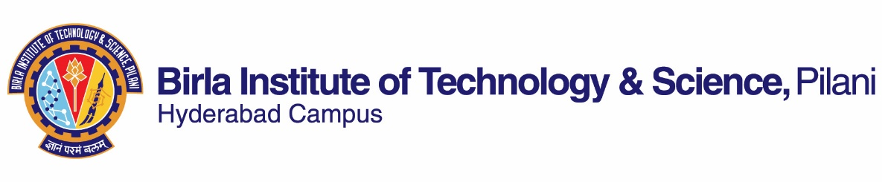
FIRST SEMESTER 2021-2022
Course Handout (Part II)
Date: Aug 20, 2021
In addition to Part I (General Handout for all courses appended to the time table) this portion gives further specific details regarding the course.
Course No : CHE F366/ F367
Course Title : Laboratory Project
Instructor-in-charge : Dr. Debirupa Mitra

1. Scope and Objective of the course:
The course is designed to provide an opportunity for students to learn to execute the research sequence comprising of the following objectives:
- To define a research problem
- To study published literature
- To draw up a hypothesis
- To strategize and develop an outline
- To design experiments.
- To conduct hands-on experimentation (design, conduct experiments, trouble-shoot and refine and replicate and most importantly, observe and monitor the entire process and soak in as many issues as possible).
- To conduct post-experimentation work (list observations, analyze and compile and finally elucidate and articulate the research conducted)

This course provides students an exposure to real-world problems, the consequence of which is an opportunity to develop skills such as, problem-solving, hands-on experimentation, logical thinking, perseverance, consistency, creativity, resourcefulness and deliberate practice. The evaluation will recognize the aspects of approach, aptitude, consistency and work ethic of students. The broad objective is to exemplify and inculcate to students the joy of continual learning and improvement.

2. Plan of Work:
The plan of work for each student will be decided by the respective mentors. Each student should adhere to the plan of work.

3. Evaluation Scheme:

S.No. | Components | Weightage % | Due Date
1. | Project Outline & Plan of Work | 05 | 03.09.2021
2. | Literature Survey | 05 | 24.09.2021
3. | Lab Related Activities – 1 | 20 | 25.10.2021
4. | Midsem Seminar | 10 | week before midsem grading
5. | Midsem Report | 10 | week before midsem grading
6. | Lab Related Activities – 2 | 30 | 05.12.2021
7. | Final Seminar and Viva | 10 | 25.11.2021
8. | Final Report | 10 | 27.11.2021

4. Mid-semester grading:
Mid-semester grading will be done after mid-semester seminar.

5. Grading Procedure:
The project outline and plan of work, weekly experimental work and interactions will be solely scored or marked (SCORE 1) by the respective faculty or mentor. The mid-semester report, mid-semester seminar, final report and final seminar and viva will be graded by a panel consisting of the mentor and two other examiners and an average score (SCORE 2) will be considered. The two other examiners will be chosen by the mentor. Further, each mentor will recommend a grade for his student after consideration of both SCORE 1 and SCORE 2 and the grades will be reported by the IC accordingly.

6. General:
It is the student's responsibility to ensure:
- Continuous interaction with the Instructor.
- Work to the satisfaction of the Instructor and adherence to plan of work.
- All Evaluations are completed within the due date.

7. Notices:
All notices pertaining to this course will be put up on the CMS.

8. Project Report
The project report shall be submitted to the instructor. The reports will be checked by the instructor using Turnitin software. A soft copy of the midsem and final report along with the turnitin report and receipt is to be submitted to the Instructor in-charge through your instructor.

9. Academic Honesty and Integrity Policy:
Academic honesty and integrity are to be maintained by all the students throughout the semester and no type of academic dishonesty is acceptable.
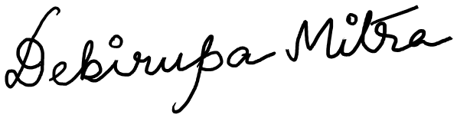
Dr. Debirupa Mitra
Instructor-In-Charge
CHE F366/ CHE F367

